

***Master ENERGIE - Decentralized Smart Energy Systems 2.0***

|  |  |
| --- | --- |
| **Optimization of A Solar pv System for a HOSPITAL IN LONDON, UK**  *TU: Smart and Flexible Energy Management Optimal Design of a local energy network* | **Prof. Julien Fontchastagner**  **Group:**  Walmy Fernández  Rashida Olomowewe  Vanesa Delgado  Morris T. Nyantee |

**Contents**

I Introduction 2

II Case Study 3

IV System Design and Optimization 6

IV. 1 Models 6

IV.2 Optimization 7

V Results and Discussions 10

Conclusions 12

Bibliography 13

# **I Introduction**

Hospitals are among the most energy-intensive facilities, requiring reliable and cost-effective power sources to ensure uninterrupted patient care. With rising electricity costs and sustainability goals, integrating renewable energy solutions such as solar PV and battery storage has become a key strategy to reduce expenses and enhance energy resilience. This study examines the feasibility of a solar-wind powered hospital in Great Ormond Street, London, UK, leveraging the Smart Export Guarantee (SEG) to monetize surplus energy while ensuring uninterrupted power availability.

Due to the hospital's high energy consumption, its energy profile was scaled down by a factor of four, resulting in an estimated annual consumption of 2.85 GWh and an electricity bill of approximately £1.06 million, assuming energy usage remains constant. The cost estimation was derived by extrapolating historical consumption data from 2016–2017 and adjusting for electricity price estimates from 2022.

A key characteristic of the hospital's energy profile is its seasonal demand variation, where cooling loads peak in summer due to air conditioning, coinciding with maximum solar irradiance. This dynamic presents a prime opportunity to export excess solar generation under the SEG scheme. By contracting with Good Energy, the hospital could earn 15 pence per kilowatt-hour (p/kWh) for exported electricity, creating a secondary revenue stream to offset costs, fund maintenance, and support future system expansions.

A battery storage system has been incorporated into the system to maximize system efficiency. A minimum SOC of 50% was chosen to balance battery longevity and economic feasibility, as lower SOC thresholds such as 40%, 30%, or 20% could increase short-term energy availability but lead to faster degradation and higher replacement costs. Our analysis compares different SOC levels to assess their impact on investment costs, operational efficiency, and energy independence.

The proposed grid-connected solar energy system is designed for self-sufficiency, utilizing the grid primarily for energy export rather than consumption. While emergency diesel generators remain available as a backup, they were not included in the system design, ensuring uninterrupted hospital operations when needed. By modeling system performance based on the monthly average consumption in 2016, this study takes a data-driven approach to optimally sizing and pricing a PV system that minimizes reliance on external power sources.

Ultimately, this study underscores how a hybrid solar-wind energy integration and strategic battery management enhance grid resilience and create a sustainable financial model for healthcare facilities. Through optimized solar utilization and smart export strategies, hospitals can transform energy expenses into long-term financial and environmental benefits, paving the way for a greener, more self-sufficient healthcare infrastructure.

# **II Case Study**

The case study focuses on a general hospital in Greater London, operating 24/7. The chosen location was a hospital located in Great Ormond Street, London, UK. The consumption data was taken between January 1st, 2016, and October 23rd, 2017, from the hospital in the zone utilizing utilizing data from [1] The hospital is a 10-floor-bulding occupying around 17,000 square meters of surface built in 2012 and its electricity load profile of this hospital doesn’t include the heating as it is provided by district heating from the city of London.

The consumption rate of hospitals is about 2 – 3 times higher than that of average commercial buildings, reflecting the intensive energy demands of healthcare facilities. The hospital's energy usage is primarily distributed among HVAC systems, lighting, medical equipment, and water heating, with each playing a crucial role in patient care and facility operations. In Table 1, the load and the electricity bill of the hospital is shown.

The primary aim of this energy optimization project is to convert the hospital to an islanded system from the grid using batteries and PV systems. This transition seeks to reduce overall energy costs and dependency on the grid while improving energy efficiency and reducing the hospital's carbon footprint. Ensuring an uninterrupted power supply for critical medical operations remains paramount, as does compliance with local and national energy regulations. The project aspires to achieve these goals while maintaining or improving the quality of healthcare services provided.

In pursuing these objectives, the project must carefully consider several factors. The hospital's peak demand patterns, which can be significantly higher than those of average commercial buildings, need to be accounted for in system design. The compatibility of existing infrastructure with renewable energy systems and energy storage solutions requires thorough assessment. The potential for on-site renewable energy generation, particularly solar PV, must be evaluated in the context of London's climate and the hospital's available space. Finally, the economic viability of large-scale battery storage systems for a facility of this size and energy profile demands careful analysis to ensure long-term sustainability and cost-effectiveness.

Table 1. Electricity Consumption in the Hospital and its cost.

|  |  |  |
| --- | --- | --- |
| **Month** | **Consumption (kWh)** | **Electricity Cost ($)** |
| January | 102,071.22 | $ 22,966.02 |
| February | 93,663.22 | $ 21,074.22 |
| March | 110,008.67 | $ 24,751.95 |
| April | 99,870.38 | $ 22,470.83 |
| May | 116,106.00 | $ 26,123.85 |
| June | 125,340.43 | $ 28,201.60 |
| July | 137,279.96 | $ 30,887.99 |
| August | 116,106.00 | $ 26,123.85 |
| September | 121,925.30 | $ 27,433.19 |
| October | 111,507.52 | $ 25,089.19 |
| November | 105,170.23 | $ 23,663.30 |
| December | 105,590.74 | $ 23,757.92 |
| **Annual** | **1,344,639.67** | **$ 302,543.93** |

**III Data Collection and Manipulation**

To evaluate the most effective energy sources and control strategy for the hospital, historical data on electricity consumption, solar irradiance, temperature, and wind speed were extracted.

**Data Collection on General Hospital**

The electricity consumption data for the case study represented the load data utilized for this study, and it was obtained from [1], which built an open-source dataset containing load profiles energy measurements from 2016 to 2017. It includes energy usage data from various non-residential buildings, including hospitals, allowing for an analysis of electricity consumption trends over the specified period.

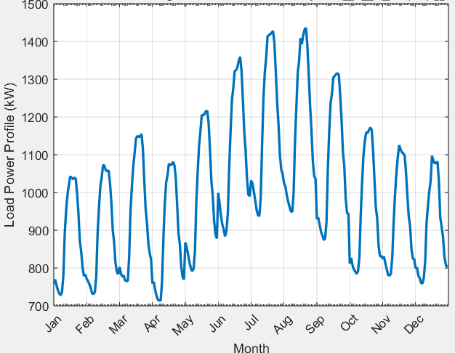**Data Manipulation on General Hospital**

Figure 1: Electricity Consumption Profile: Averaged Hourly Data by Month

For this project, the 2016 electricity consumption data for the General Hospital was first extracted and analyzed using Python to determine the best approach for studying consumption patterns. Based on this analysis, the data was averaged to represent hourly values for each month, ensuring key trends were retained while smoothing fluctuations to highlight seasonal variations.

The data was then processed and cleaned in MATLAB, where duplicates were removed, missing values were handled, and the data was plotted for visual analysis. These refined insights formed the basis for configuring the microgrid control strategy, as shown in Figure 1.

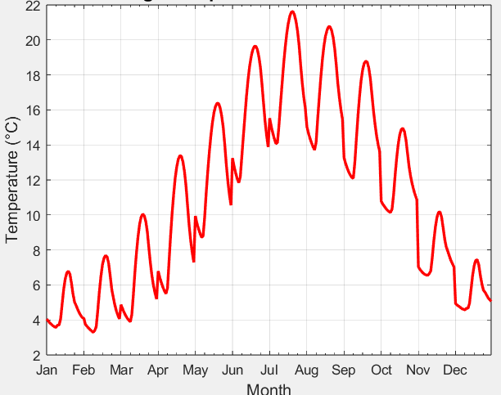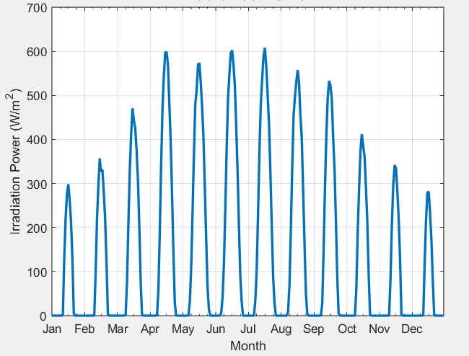**Data on Solar PV and Temperature**

Figure 2: Hourly-Averaged Solar Irradiance and Temperature Profile by month

Solar PV is a viable energy source for the hospital, as London receives 2.5–4.5 kWh/m²/day of solar radiation, covering significant demand. To optimize the hospital’s Solar PV system, solar irradiance and temperature data were obtained from the PVGIS (Photovoltaic Geographical Information System) database. The data was extracted using the tool available at [PVGIS](https://re.jrc.ec.europa.eu/pvg_tools/en/) [7], with the hospital’s specific coordinates (51.521939, -0.120069, Europe/London time zone).

Daily solar irradiance and ambient temperature values for the entire year 2016 were selected to match the electricity consumption dataset. The Hourly-Averaged Solar Irradiance for each month of the year values were processed using Excel and MATLAB to align with the energy analysis and optimization framework. The graphical representation of the irradiance and temperature is as seen in figure 2.

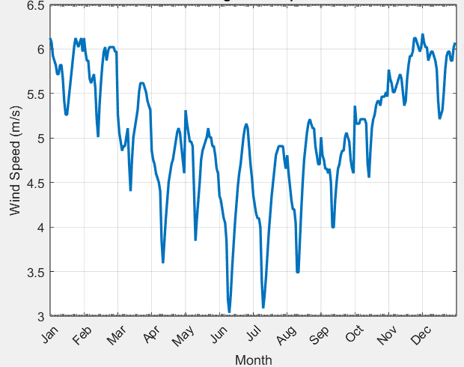**Data on Wind speed**

Wind turbines were chosen as an appropriate backup source for PV because they provide resilience during periods of low solar generation. Small-scale urban wind turbines can harness London’s average wind speeds of 4–6 m/s, enhancing system reliability. Wind energy offsets solar limitations, especially in winter and nighttime, ensuring year-round power.

To assess their feasibility, wind speed data for the hospital’s location was obtained from the Global Wind Atlas [8], using the hospital’s coordinates. Hourly wind speed values for 2016 were extracted and processed in Excel and MATLAB to analyze the hourly-averaged wind speed for each month, aligning with the energy analysis framework. A graphical representation of wind speed trends is shown in Figure 3.

Figure 3: Hourly-Averaged Wind Speed Trends by month

Conclusively, the analysis of the hospital’s energy feasibility reveals that a hybrid PV-Wind system is the most viable solution, given the seasonal variations in solar irradiance, wind speed, and load demand. The irradiance profile peaks in July at approximately 600 W/m² and drops significantly in December to nearly 100 W/m², indicating that solar PV alone will not be sufficient in winter.

The temperature profile follows a similar seasonal trend, reaching 22°C in July and dropping to 4°C in December, which may slightly impact PV efficiency due to temperature-related performance losses. The wind speed data shows an inverse relationship with solar availability, averaging 6.2 m/s in winter (December–February) and decreasing to 3.5 m/s in summer (June–August).

This suggests that wind turbines can compensate for reduced solar generation in winter. The load profile indicates higher energy demand in summer (~280,000 kW) and winter (~220,000 kW), driven by cooling and heating requirements, reinforcing the need for energy storage or grid backup to manage fluctuations. Given these conditions, a PV-Wind-Battery hybrid microgrid is the optimal choice, with PV covering peak summer demand, wind supporting winter months, and batteries ensuring nighttime and backup energy supply

# **IV System Design and Optimization**

## **IV.1 Models**

**Solar Panel: PV Monocrystalline N-Type TOPCon**

Given London’s irradiance profile (~600 W/m² in summer, ~100 W/m² in winter), a high-efficiency PV module was essential. The selected Astronergy panel [2] offers strong performance and reliability throughout the year, as shown in Table 2 .

Table 2: Electrical Performance Specifications of the PV panel

|  |  |
| --- | --- |
| Parameters | Model |
| Rated Maximum Power Point (Pmpp) | 485W |
| Temperature Coefficient (%/℃) | -0.29 |
| Cost | 148.57€ |
| Linear degradation (%/year): | 0.4 |
| Module Efficiency: | 22.4% |

**Battery: Lithium Iron Phosphate Battery**

To address seasonal demand variations and support energy storage, Pylontech US5000 [3], was selected for its high efficiency, long cycle life, and deep discharge capability, as outlined in Table 3

Table 3: Specifications of the Pylon tech US5000 Battery System

|  |  |
| --- | --- |
| Parameters | Model |
| Capacity | 4560 Wh |
| Efficiency | 98% |
| Cost | 255.39€ |
| Depth of Discharge | 95% |

**Wind Turbine:**

The turbine [4] was selected to match London’s average wind speeds (4–6 m/s), with a low cut-in speed and compact design that suits limited space. Key specifications are provided in Table 4.

Table 4: Technical Specifications of the Selected Wind Turbine

|  |  |
| --- | --- |
| Parameters | Model |
| Starting wind speed | 2.5 M/s |
| Nominal wind speed | 10 M/s |
| Nominal output power | 1000W/1500W/2000W/5000W |
| Efficiency | 92% |
| Cost | 623$ |
| Rotor diameter | 1.9 |

**Inverter:**

The inverter models [5] used are mentioned in Table 5, along with their efficiency.

Table 5. Inverter’s Models.

|  |  |  |
| --- | --- | --- |
| **Component** | **Model** | **Efficiency** |
| DC-DC Converter | Orion XS-12-12 50A | 98.5 % |
| AC-DC Converter | SMA STPS-60 | 98.8 % |
| AC-DC for Wind | DM FKJ-MPPT | 98.5 % |

## **IV.2 Optimization**

An optimization model has been developed and implemented in the MATLAB environment to find the best combination of PV, small wind turbines, and battery components to minimize the investment costs associated with both technologies.

The optimization technique employed in this work is the Genetic Algorithm (GA), a method used to solve both constrained and unconstrained optimization problems, inspired by the principles of natural selection, which drive biological evolution. This algorithm continuously updates a population of potential solutions, selecting individuals from the current set to serve as parents (MATLAB, n.d.).

**Objective function**

The objective function aims to minimize the total investment cost of the system. The variables involved in this optimization are:

* Npv: Number of PV panels.
* Nturb: Number of wind turbines.
* Ncell: Number of battery cells.
* SOC_ini: Initial State of Charge of the battery.

The objective function is defined as

obj = @(X) (X(1) * (Cinv_panel + OPEX_PV_total) + ...

X(2) * (Cinv_cell + OPEX_Battery_total) + ...

X(3) * (Cinv_turb + OPEX_Wind_total)); (1)

Where Cinv_panel, Cinv_cell, and Cinv_turb and OPEX are the investment costs for PV, battery cells and wind turbines respectively.

**Constraints**

The defined constraints in the script are:

* **SOC Constraints:** The State of Charge (SOC) of the battery must always stay within a specified range, SOC_min to SOC_max (0,5 to 0,9).
* **Power Supply Constraints:** The battery and PV system must supply sufficient power to meet the load requirements, and excess energy that cannot be supplied must be exported. In our problem, P_unsup tracks any unsupplied power, and the constraint ensures that it stays within a certain limit.
* **Space Constraints:** The hospital is in a urban area so the available surface is limited. It was estimated that the useful area is about 80 % of the total area which is 17596.62 m2. After defining the area of a PV panel and based on the rotor diameter, the wind turbine spacing the maximum amount of PV panels and wind turbines are calculated.
  + Npv​×P_area​+Nturb​×Arequired_per_turbine ​≤ Ausable​

**Control Design**

This flowchart in figure 6. illustrates the control logic for managing power flow in the hybrid microgrid system. It prioritizes meeting the load demand with PV and wind generation, then determines if there is excess energy. The system checks the battery SOC to charge or export excess energy, while the battery compensates for shortages to maintain stability.

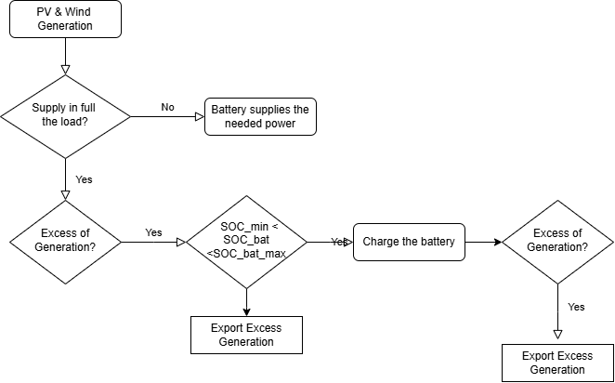

Figure 4. Logic of the off-grid system.

**PV Generation**

The formula for computing the power produced by a single PV panel is as follows:

P_PV = (Npv*eta_PV*P_PV_STC/G_STC*(1+CT*(T_PV-T_STC)).*GSR)*(1-r_deg)^(year-1) (2)

The power produced by the PV system is determined by several factors. First, the number of panels, their efficiency and rated power under Standard Test Conditions (STC), adjusted by dividing by the standard irradiance of 1000 W/m² to normalize the output. Since the temperature is variable, a temperature correction factor is included. One additional parameter added to the model is the degradation overtime of the PV panel. The degradation is factored into the formula by applying a yearly degradation rate, which diminishes the output accordingly as the system ages according to the degradation of the given PV panel model.

**Wind Generation**

On the other hand, to compute the power produced by a single wind turbine, the following formula retrieved from [6] is used:

P_wind = Nturb *(A + (B* w_speed) + (C* (w_speed)^2)) * P_turb (3)

The power produced by the wind turbines will depend on the wind speed, the rated power capacity and the coefficients A, B and C which can be calculated from the following formulas.

A = (1./(vci - vr)^2)* (vci*(vci + vr) - 4*vci*vr*((vci + vr)/(2*vr))^3)); (4)

B = (1/((vci - vr)^2))*(4*(vci + vr)*(((vci + vr)/(2*vr))^3) - (3* vci + vr)); (5)

C = (1/((vci - vr)^2))* (2 - 4*((vci + vr)/(2*vr))^3))); (5)

Where vci (m/s) is minimal wind speed and vr (m/s) is operating wind speed.

**Proposed System Design**

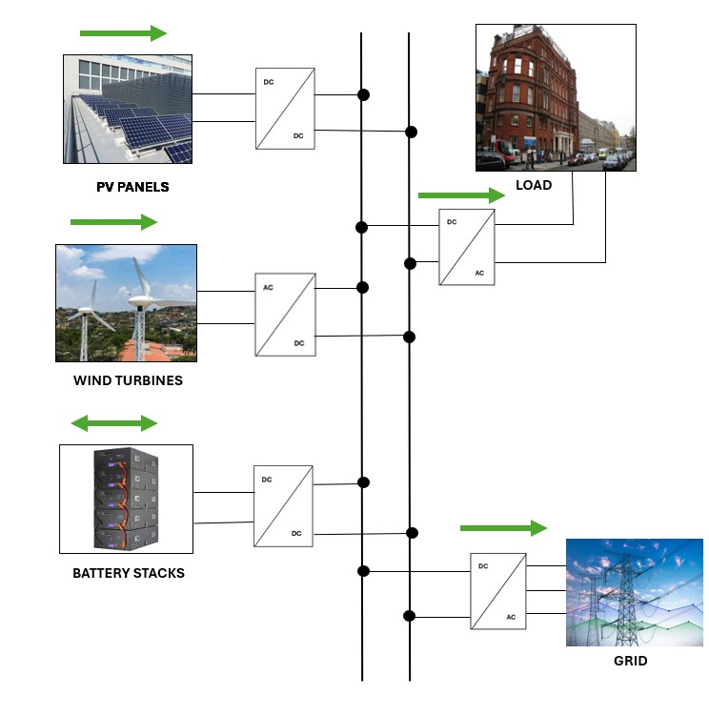The proposed hybrid energy system integrates solar PV, wind turbines, and battery storage through a DC microgrid to reliably power the hospital in London. PV and wind supply the load directly, while surplus energy charges the battery or is exported to the grid. If renewable supply is insufficient, the battery discharges to meet demand. A control strategy ensures efficient power flow, prioritizing load, optimizing battery use, and maximizing renewable utilization, all while supporting the UK’s Smart Export Guarantee scheme.

Figure 5: Proposed Hybrid DC microgrid with PV, wind, battery, load, and grid connection.

# **V Results and Discussions**

The following sections discuss key findings on energy production, system sizing, financial viability, and long-term sustainability.

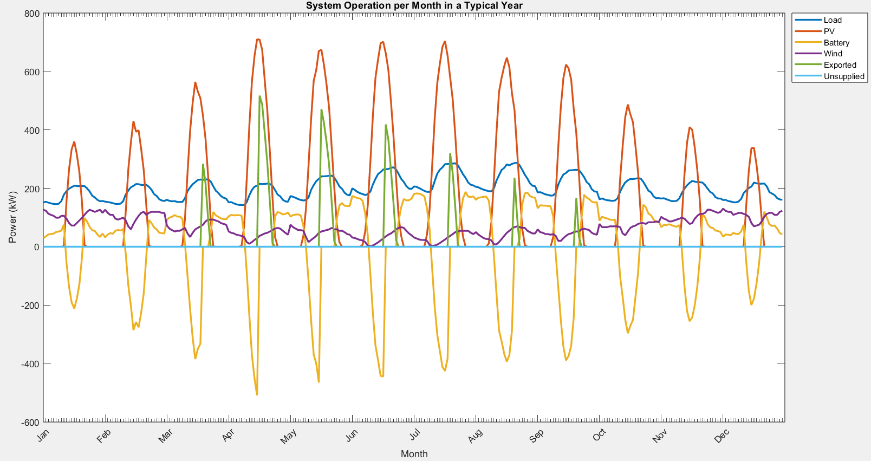Figure 7. illustrates how the optimized system balances generation and demand. PV output peaks at 600 kW in summer and drops below 100 kW in winter, while wind power (50–150 kW) remains stable, compensating for seasonal solar variations. Battery storage (200 kW) smooths fluctuations by charging during high generation periods and discharging when demand exceeds supply. Exported power (400–600 kW) is significant in summer, while unsupplied load remains close to zero, indicating efficient system sizing. However, reliance on storage and wind increases in winter due to reduced solar availability, highlighting the importance of optimized energy management for year-round reliability.

Figure 6: System Operation per Month in a Typical Year.

The optimization results indicate an optimal configuration of the renewable energy system, balancing cost efficiency and energy supply reliability. The solution provides the following key component capacities:

* PV Panels: 2,504 units (1.21 MW).
* Wind Turbines: 530 units (1.06 MW).
* Battery Storage: 304 units (1.39 MWh).
* Final State of Charge (SOC): 0.65.

The total system cost associated with this configuration is €1.824 million. This result reflects the trade-offs between capital expenditure and operational performance, ensuring adequate energy generation while maintaining cost-effectiveness. The system design prioritizes solar energy as the primary source, with wind turbines and battery storage playing a complementary role to enhance energy security and grid independence. The unsupplied power is maintained at zero and the SOC of the battery doesn’t fall below 0.5 respecting the constraints of the BMS.

Figure 7: Energy exported to the grid.

The system is designed to work for at least 10 years considering the degradation of the PV system, and the load growth over that time considering a yearly increase of 2.5%. This adjustment ensures that the system reflects real-world conditions, accounting for gradual demand escalation over time. Nonetheless, as can be seen in figure 7, a significant amount of energy needs to be exported to not get wasted.

The energy produced in excess by the system will be exported using the Smart Export Guarantee mechanism (SEG), designed by the United Kingdom to support small-scale renewable energy producers by compensating them for the excess of electricity they export to the grid. The programme is limited to those who have less than 5 MW capacity in total from the renewable energy systems. Our system is below this threshold; hence it is applicable to us.

It was assumed that the customer will sign a contract with Good Energy under the SEG scheme, receiving a rate of 15 pence per kilowatt-hour (p/kWh) for exported electricity. To ensure seamless participation in the SEG, a smart meter capable of recording half-hourly export readings will be required. As seen in Table 6. Cash flow analysis.Table , knowing the electricity bill, and other data, the cash flow was made and it was concluded that the payback for the project is 6 years with a TIR of 15.42 % over the next 10 years.

Table 6. Cash flow analysis.

|  |  |  |
| --- | --- | --- |
| **Year** | **Cash Flow\*** | **Cumulative Cash Flow** |
| 0 | $ (1,824,000.00) | $ (1,824,000.00) |
| 1 | $ 341,714.14 | $ (1,482,285.86) |
| .  .  . | .  .  . | .  .  . |
| 10 | $ 418,888.42 | $ 1,966,319.11 |

*Note: Cash Flow is the sum of energy savings by not buying from the grid plus revenue for energy exported.*

# **VI Conclusions**

The culmination of our research presents a strong case for the integration of solar PV, small-scale wind turbines, and battery storage as part of an off-grid energy solution in a high-demand facility such as a hospital. By carefully analyzing Great Ormond Street Hospital’s unique energy usage patterns, we were able to size an optimized system that minimizes reliance on the grid without compromising patient safety or critical medical operations.

In particular, the synergy between solar, wind, and battery assets ensures that each energy source is used to its greatest advantage. Solar PV capitalizes on peak summer irradiance, wind turbines supplement year-round generation, and battery storage supplies demand fluctuations.

Financially, the proposed configuration, while representing a considerable initial investment, shows a payback period of approximately six years and an Internal Rate of Return of 15 %. These figures are boosted further by the Smart Export Guarantee scheme, through which surplus energy generation not used on-site can be resold to the grid. The combination of cost savings on imported electricity plus export revenue makes the system an appealing prospect for hospital management and stakeholders.

With thoughtful planning, technical due diligence, and a willingness to adapt these solutions to local conditions, hospitals can become resilient power hubs—leading the charge toward a more sustainable and fiscally responsible future for healthcare.

# **Bibliography**

1. Miller, C., Kathirgamanathan, A., Picchetti, B. et al. The Building Data Genome Project 2, energy meter data from the ASHRAE Great Energy Predictor III competition. Sci Data 7, 368 (2020). https://doi.org/10.1038/s41597-020-00712-x
2. Astronergy N5s N-Type Monofacial Solar Panel - 485W Black Frame - Solar Trade Sales. https://www.solartradesales.co.uk/astronergy-n5s-n-type-monofacial-solar-panel-485w-black-frame.
3. https://www.solartradesales.co.uk/pylon-us5000-1c-4-8kwh-li-ion-solar-battery-latest-model?cat=9702#overviewTab [Internet]. Pylon US5000-1C 4.8kWh Li-Ion Solar Battery (Latest Model) - Solar Trade Sales.
4. https://demingpower.en.made-in-china.com/product/BmfpbaICsxRX/China-2kw-MPPT-AC-to-DC-Converter-Wind-Generator-Charger-Wind-Turbine-Controller.html [Internet]. 2kw MPPT AC to DC Converter Wind Generator Charger Wind Turbine Controller.
5. Orion XS DC-DC battery charger 12/12-50A [Internet]. Available from: www.victronenergy.com
6. Raff R, Golub V, Knežević G, Topić D. Modeling of the Off-Grid PV-Wind-Battery System Regarding Value of Loss of Load Probability. Energies (Basel). 2022 Feb;15.
7. Global Solar Irradiance.
8. Global Wind Atlas.
9. Solar Technology SA. SUNNY TRIPOWER STORAGE 60 - Highest power density for flexible applications.